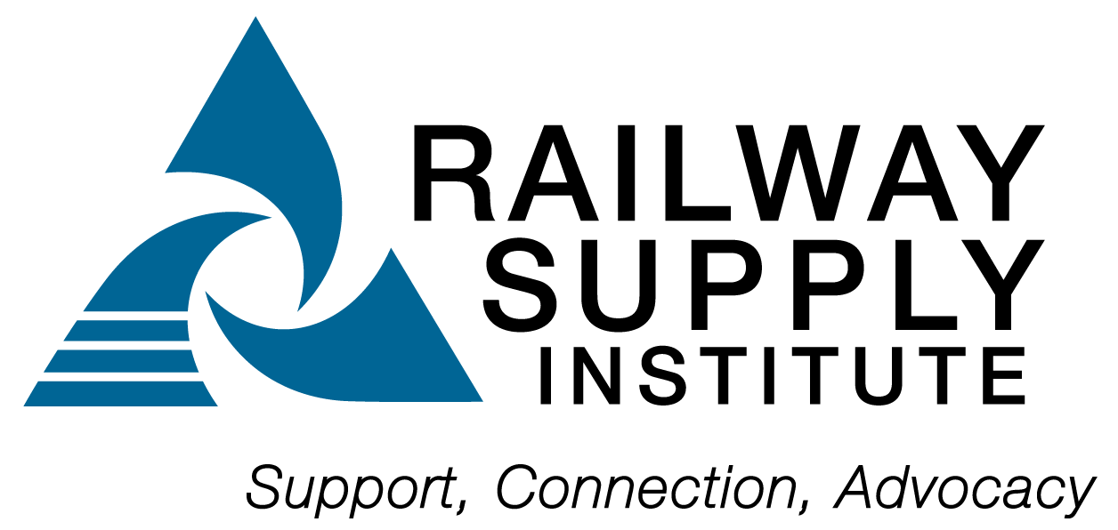 RSI Quality Newsletter
  - Volume 24, 1st Quarter 2026
  - Audit finding examples – By Newsletter Team
Inside this issue
Page 1 – Audit Finding Examples
Page 1 – Standard of the Quarter
Page 1 – Railway Interchange
Page 1 – Mandatory Elements
Page 2 - Training Dates & Useful Links
Page 3 - Contributors

  - During an internal audit, it was discovered that the thread gages used by the valve room for rebuilding safety valves and other tank car valves were not listed on the gage calibration record. The gages were calibrated and in use. They all had calibration stickers with an in-service date and calibration due date. The finding consisted of noncompliance with 2.8 Measuring and Test Equipment. AAR MSRP, Section J, paragraph 2.8.4 requires that calibration records include the date of calibration, reference to standard applied, equipment type, unique identification number and location of the equipment. The noncompliance finding was written and referenced the paragraph. The auditee responded by stating the corrective action was completed immediately, and the gage calibration record was updated. The root cause using the five-why tool was determined to be the new QA Manager was not aware the thread gages were put in service by the previous QA Manager.

  - Based on the root cause, what would your preventive action be for this audit finding? Email your thoughts to cwall@rsiweb.org

Standard of the quarter – By Newsletter Team

In this newsletter feature, we will review a standard or specification for your educational benefit. Please provide your feedback of this feature to any QAC Committee members listed on the last page of the newsletter.

Section A1 Tables of Content of the AAR Standards and Recommended Practices (MSRP) provides the user with helpful information on all the appendices of the standards and recommended practices along with useful information on who to contact for technical questions including the AAR Tank Car Committee, Wheel, Axle and Brake Committee, and other Technical Committees. Use the email address listed for the committee to ask for interpretations of AAR rules. This is very helpful at audit time and for training purposes.

Railway interchange 2026 – By Newsletter Team

The QAC thanks Dave Ronzani, Director, Railcar Regulatory Compliance at AllTranstek, and Rob Sech, VP of Operations at Modern Rail Company, who co-presented Tank Car Qualification Past and Current at Railway Interchange June 2 – 4 in Omaha.

2026 Mandatory elements
The AAR QAC announced the following elements as mandatory:

2.5 – Production Inspection and Test Planning
2.6 – Corrective and Preventive Actions
2.11 – In-process Inspection
2.12 – Final Inspection

2026 AAR M-1003 Quality assurance training schedule
Course | date | location
basic auditor  training class | March 24-26 | san diego, ca
basic auditor  training class | april 14-16 | mexico city, mx (spanish)
basic auditor  training class | june 2-4 | kansas city, ks
basic auditor  training class | july 21-23 | calgary, ca
basic auditor  training class | september 15-17 | virginia beach, va
basic auditor  training class | october 27-29 | nashville, tn
advanced auditor  training class | march 10-12 | mira loma, ca
advanced auditor  training class | may 19-21 | kansas city, mo
advanced auditor  training class | september 29 – october 1 | marmaduke, ar
advanced auditor  training class | october 13-15 | monclova, mx (spanish)

USful links

Railway Supply Institute
RSI QAC & Previous Newsletters
RSI Tank Car Resource Center
Registry of M-1003 Certified Companies
M-1003 Frequently Asked Questions
American Society for Quality - Training
RSI 100
AAR M-1003 Certification on-line Application
AAR M1003, Section J Specification for Quality Assurance
AAR Training Schedule
AAR Circulars
MSRP Publication Current Revision Status
AAR Online Material Nonconformance Reporting System (Chapter 7)
AAR FAQ Page includes QAPE

The following RSI QAC members worked on this newsletter:

Gary Alderson – AllTranstek – alderson@alltranstek.com
Alfredo Ricardo – AllTranstek – ricardo@alltranstek.com
Ben Masters – Progress Rail – bmasters@progressrail.com

The information given in this newsletter is for informational and educational purposes only. It is not intended to provide legal advice and should not be relied upon to make business decisions about any existing, future, or prior rule, regulation, or interpretation.
Sanjay Varma – Progress Rail – svarma@progressrail.com
Carrie Wall – RSI –
cwall@rsiweb.org

